JoMUN XVI
Forum: Historic Security Council
Issue: The Congress of Vienna - 1815
Student Officer: Ayushi Banerjee
Position: President

INTRODUCTION
Following the Napoleonic Wars, The Congress of Vienna, which took place from 1814 to 1815, was called to ensure long-term peace among European countries, achieved by reorganizing European borders to restore the balance of power. Although it officially began in November 1814, delegates had started negotiating terms as early as September 1814 following the first abdication of Napoleon I. The Final Act of the Congress of Vienna was completed in June 1815, preceding Napoleon’s final defeat at Waterloo. Although almost every state in Europe was represented, the Great Powers of Austria, Britain, Russia, Prussia, and France functioned as the primary decision makers. The main points of friction were regarding the division of Poland, and whether King August Friedrich of Saxony, a firm ally of Napoleon, would retain any of his lands. The Final Act was signed by all the major European powers except for Spain, which refused to accept the treaty until 1817. This became one of the most comprehensive treaties that Europe had seen, securing around half a century’s worth of relative peace within Europe, ended only by Germany’s unification in 1871.

PROCEDURES OF THE HISTORIC SECURITY COUNCIL FOR THIS ISSUE
Since the United Nations did not exist in 1814, at the time of the Congress of Vienna, the Historic Security Council will simulate a conference where delegates represent their relevant countries. Relevant countries in the Congress of Vienna will be chosen by the chairs and supervisors. These countries will be different for the Rwandan Genocide issue.
The goal of the HSC will be to form a resolution that defines post war order. The aim is to make peace in Europe following the Napoleonic wars, which entails the redistribution of power, which became disproportional over the course of the wars, as well as decisions on which countries need to be punished or contained, and how this shall be done.

DEFINITION OF KEY TERMS
Napoleonic Wars
A series of armed conflicts resulting from the French Revolution between the French empire, under Napoleon’s leadership, and a number of different European powers, financed primarily by Britain.
Great Powers
A sovereign state with global influence, which usually has its own economic and military strength.
Duchy
Any country or territory under the leadership of a duke or duchess.
Hundred Days
The short period of time between when Napoleon escaped from his exile on March 20, 1815, and when King Louis XVIII was restored to the throne on July 8, 1815. The Battle of Waterloo, where Napoleon faced his final defeat, took place during this time.
Balance of power
An international relations theory about increased national security resulting from evenly distributed military capacity among states so that no one state is disproportionately more powerful than the others.
The Allied Powers
Comprised of Austria, Britain, Prussia, Russia, Sweden, and Portugal.

BACKGROUND ON THE ISSUE AND TIMELINE OF EVENTS
11th April 1814 | The Treaty of Fontainebleau is signed between the allied powers and France, ensuring the abdication and exile of Napoleon Bonaparte to Elba, thus putting a temporary stop to the Napoleonic Wars.
30th May 1814 | France and the allied powers sign the First Treaty of Paris, which provides a general overview of the redistribution of European territories taken from the French empire. This treaty also called for the Congress of Vienna as a way for the powers involved to finalize the general terms of this treaty.
September 1814 – June 1815 | The Congress of Vienna is in session.
3rd January 1815 | Britain, Austria, and France sign a secret treaty binding them together against Russia and Prussia.
20th March 1815 – 8th July 1815 | The duration of the Hundred Days, marked by the return of Napoleon to France from his exile in Elba. The Duke of Wellington leaves the Congress of Vienna to lead the allied forces into the battle of Waterloo in June, forcing Napoleon’s final abdication and exile to St. Helena. Louis XVIII regains the throne in July.
9th June 1815 | The Final Act is signed by everyone at the Congress except Spain. Its principal results are the enlargements of Russia and Prussia, Germany’s consolidation into the German Confederation, which is placed under Austrian and Prussian leadership, and the France’s loss of the territories it had annexed from 1795 to 1810.
18th June 1815 | Napoleon is defeated by the allied powers in the Battle of Waterloo.
20th November 1815 | The second Treaty of Paris is signed between France and the allied powers. The treaty stripped France of its territories Saar and Savoy, and bound France to pay a hefty compensation of 700,000,000 francs and also to allow an army of occupation in the country for up to five years.
7th May 1817 | Spain accepts the Final Act of the Congress of Vienna.

KEY COUNTRIES AND ORGANIZATIONS INVOLVED
France
The French Revolution, followed by the Napoleonic Wars, was the main reason for the need for the Congress of Vienna to reorganize Europe. Initially the four victorious powers hoped to exclude France from impacting the negotiations. Represented at the Congress by its foreign minister Talleyrand and the Duke of Dalberg. Talleyrand inserted himself into the negotiations in an attempt to secure a relatively favourable outcome for France despite Napoleon’s conquests. France ended up losing all of the territories it had gained through the Napoleonic Wars. Additionally, as a result of the second Treaty of Paris, France had to give up Saar and Savoy, pay an indemnity, and allow an army of occupation within its borders for up to five years. However, France did receive Guadeloupe from Sweden, the French Guiana from Portugal, as well as Martinique and the Isle of Bourbon from Britain. This was an attempt to establish a balance of power in Europe to prevent future conflicts.
Austria
Since the Congress was conducted in Vienna, Emperor Francis of Austria remained updated on its proceedings. The Austrian representative Metternich approached the matter with a conservative perspective, favouring the preservation of the status quo, or the return to the political state before the Napoleonic Wars. He was also extremely wary of Russian dominance, opposing concessions to Russia as well as Prussia. Some argue that had Metternich been open to the ideas of liberalism and nationalism, Austria may have been able to reform and even solve its nationalistic problems. Ultimately, this could even have prevented the First World War.
Britain
Britain had a very strong position in the negotiations due to the reputation of its armed forces. Its first representative, Viscount Castlereagh had similar conservative views as Metternich, believing that the combined efforts of the great powers could secure long-term peace in Europe. At the same time, he also believed that a treaty seeking revenge on France would fail to restore the balance of power, and thus argued to block harsh terms for France so that it could come back into diplomatic balance. Additionally, Britain was strongly against concessions to Russia and Prussia, along with Austria and France, which lead to them signing a secret treaty in January 1815.
Although it seemed as though Britain gained little from the settlement, especially considering its expenditure on the wars, it gained much colonial strength which proved beneficial to its trade, which helped Britain establish itself as the main colonial power of Europe.
Russia
The Tsar of Russia, Alexander I, hope for three outcomes from the Congress: Russian control over Poland, the formation of a league with the power to intervene in and prevent revolutions against monarchies, and the peaceful coexistence of countries within Europe. He succeeded in gaining much of Poland, and forming the Holy Alliance, a group based on anti-secularism and monarchism. Russia was also strongly against the idea of France being allowed to negotiate the terms on the Treaty.
Russia’s expansion enabled it to enter western Europe as a major power, playing a regular and important part in European diplomacy from 1815 onwards.
Prussia
The Prussian representative, Prince Karl August von Hardenberg, was relatively liberal, especially when compared to the other principal participants of the congress, and had already implemented some liberal reforms earlier in his career. Prussia wanted control over Saxony, and proposed a deal along with the Russians in which the Russians gained Poland, and Prussia gained Saxony. The British, Austrians, and French were strongly against this suggestion, which lead to them signing a secret treaty in January 1815, where they agreed to wage war on Russia and Prussia if the need arose. In the end, this was avoided through negotiation.
Previously threatening war if it was not granted territory, Prussia finally received 40 percent of Saxony, as well as territories in Sweden and Poland.
Spain
Although Spain was a second power, and had next to no influence on the negotiations, it stands out as the only country which refused to sign the final act as a protest against the Italian settlement with the Duchy of Parma. However, it ended up accepting the treaty by 1817 for fear of standing alone instead of being a part of Europe.

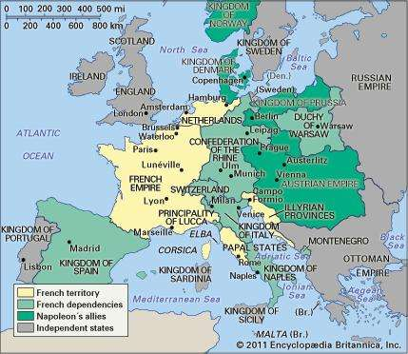
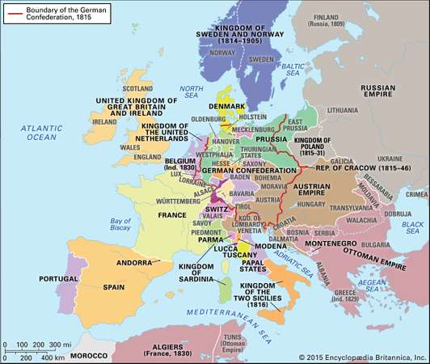
MAPS
Figure 1: Europe in 1812, before the Congress of Vienna
Figure 2: Europe in 1815, after the Congress of Vienna

POSSIBLE SOLUTIONS
The treaty formed by the HSC must consider the following points:
- Redistribution of French territories acquired during the Napoleonic wars.
- Containment or punishment for Napoleon and his allies.
- How to protect smaller, less powerful, and vulnerable European countries.
- The even distribution of power across Europe, negotiated in such a way that won’t breed displeasure and lead to further conflict in the continent.

WORKS CITED
Bloy, Marjie. “The Congress of Vienna, 1 November 1814 — 8 June 1815.” The Victorian Web, National University of Singapore, 30 Apr. 2002.
Britannica, The Editors of Encyclopaedia. “Congress of Vienna.” Encyclopædia Britannica, Encyclopædia Britannica, Inc., 9 Aug. 2017.
Britannica, The Editors of Encyclopaedia. “Hundred Days.” Encyclopædia Britannica, Encyclopædia Britannica, Inc., 13 Mar. 2018.
Britannica, The Editors of Encyclopaedia. “Napoleonic Wars.” Encyclopædia Britannica, Encyclopædia Britannica, Inc., 22 Feb. 2017.
Britannica, The Editors of Encyclopaedia. “Treaties of Paris.” Encyclopædia Britannica, Encyclopædia Britannica, Inc., 17 July 2016.
“Congress and Treaty of Vienna.” New World Encyclopedia, 20 Mar 2017.
Davey, Kate. “On This Day: Napoleon Forced to Abdicate.” FindingDulcinea, 11 Apr. 2011.
“Napoleon's 100 Days.” European History Research Centre, Warwick, 7 July 2015.
“The Congress of Vienna.” FutureLearn, University of Southampton.
“The Congress of Vienna.” Lumen, Lumencandela.
“The Vienna Congress (1814-1815).” Iberoamerican Independence Bicentennial, Ministry of Education, Culture and Sport, 4 Dec. 2015.

APPENDIX OR APPENDICES
https://www.britannica.com/event/Congress-of-Vienna#ref325787
This website provides a useful basic overview of the Congress of Vienna. The related articles at the bottom of the page provide specifics on the different countries involved in the Congress.
https://www.britannica.com/event/Napoleonic-Wars/The-campaign-of-France-1814#ref336896
Explanation of the Congress in the context of the Napoleonic Wars.
https://courses.lumenlearning.com/boundless-worldhistory/chapter/the-congress-of-vienna/
This is a website explaining the Congress of Vienna in depth with helpful summaries and definitions.
https://www.futurelearn.com/courses/wellington-and-waterloo/0/steps/24837
Simple and clear outline of conflicts and tensions between the nations at the Congress of Vienna.

